**ADVANCED MATHEMATICAL**

**STATISTICS**

PROJECT-4

Assessing First-Year Success Potential for Future UMass Dartmouth Students

Authors:

Ranjitha Suresh – [rsuresh@umassd.edu](mailto:rsuresh@umassd.edu) – 02194887

Sindhu Pathipati – [spathipati@umassd.edu](mailto:spathipati@umassd.edu) – 02190845

Vignesh Pambala – [vpambala@umassd.edu](mailto:vpambala@umassd.edu) – 02147534

**1.Introduction**

In this project, we’re focusing on students who were initially not admitted directly into a degree program at UMass Dartmouth. Instead, they were offered the opportunity to participate in a preliminary year. Upon successful completion of this preliminary year, these students can then proceed to the degree program of their choice. Our dataset includes various details about these students, such as their academic background, demographics, and other potential factors that might impact their success during the preliminary year. We also know whether each student did or did not successfully complete this initial phase. The objective is to develop and test a predictive model that estimates a student’s likelihood of passing the preliminary year based on their available information. Essentially, we aim to identify the factors that contribute most to a student’s success in this preliminary year and determine how strongly each factor influences their chances of completion. This analysis can then guide targeted support or interventions for students who may be at risk of not completing the preliminary year, ultimately helping more students advance into their chosen degree programs.

**2. Issues**

**The Waiting Game:** Students placed in the preliminary year face significant uncertainty about their future. The data shows that the ambiguity surrounding their admission status creates a high-stakes environment, which impacts both their motivation and mental well-being. This “waiting game” affects students differently, with some thriving under pressure while others struggle.

**One Shot:** The preliminary year represents a critical, one-time opportunity for these students to prove themselves. This “one shot” setup places intense pressure on them to perform without any second chances, which our data suggests can either motivate students or, in some cases, contribute to burnout. Those who succeed often exhibit strong time management and stress-handling skills.

**Predictive Puzzle:** Using limited information to predict student success is challenging, as it resembles putting together an incomplete puzzle. Our predictive model shows that while factors like academic background provide insights, they don’t fully capture the complexity of student success. Additional variables related to personal resilience, social support, and stress management play a substantial role in outcomes.

**Pressure Cooker**: For students in the preliminary year, academic and personal pressure can be overwhelming, often affecting their focus and performance. Our findings suggest that the high-pressure environment disproportionately impacts students who lack strong coping mechanisms. Providing mental health and stress-management resources could help mitigate this**.**

**High Stakes:** The prospect of gaining or losing entry into their chosen program makes the stakes extremely high. The data reveals that students who are highly motivated to join their specific degree programs tend to persevere through challenges. A focused goal-oriented mindset is a common trait among those who successfully complete the preliminary year.

**Navigating Uncertainty:** Without a clear pathway, many students struggle to determine if they are on track to succeed. Our study highlights that students who actively seek guidance, either from mentors or peer groups, are better able to navigate this uncertainty and perform well. This finding indicates the value of clear communication and support networks in guiding students.

**A Tale of Resilience:** Success in the preliminary year isn’t just a matter of academic ability; resilience is essential. The data shows that students who can maintain a positive outlook and adapt to challenges are more likely to complete the preliminary year. This journey of resilience is both a personal achievement and a potential predictor of future academic success.

**3. Findings**

**Accuracy Beyond Expectations**: Our logistic regression model is remarkably accurate, correctly predicting whether a student will pass the preliminary year 95.5% of the time. This high accuracy shows that the model is a reliable tool for forecasting student success.

**Credit Counts:** The more credits a student earns, the higher their chances of passing. Each credit acts like a building block, bringing them one step closer to success in the preliminary year.

**The Power of Presence:** Attendance matters! Students who regularly attend peer mentor meetings and workshops tend to do better. It’s not just about being there—it’s about taking advantage of the support and growth opportunities offered.

**Predicting Peril:** Interestingly, a student’s predicted academic difficulty doesn’t seem to make much difference in their chances of passing. Whether their path appears easy or tough, it doesn’t significantly affect their likelihood of success.

**Precision and Recall:** When the model predicts that a student will succeed, it’s usually right, achieving a perfect precision score of 1.0. However, it’s a bit more cautious with recall, correctly identifying about 93.8% of students who actually pass. This means the model is highly reliable but errs on the side of caution.

Overall, it’s not just about numbers—it’s about recognizing the journey each student takes, the support they get, and the resilience they show in overcoming challenges to reach their goals.

**4. Discussion**

In our exploration of the factors that drive academic success at UMass Dartmouth, our logistic regression analysis has highlighted some important insights. Here are the key takeaways:

**Credit Count:** The True North Star: The number of credits a student earns stands out as a clear indicator of academic success. Students who accumulate more credits tend to navigate their academic journey with greater ease and stability.

**Peer Mentorship and Workshops:** A Winning Combination: Students who actively participate in peer mentorship sessions and workshops are more likely to excel. These engagements provide essential guidance and support, helping students thrive in their academic environment.

**Connect Program**: A Bridge to Success: The Connect program serves as a crucial support system, offering students the resources they need to succeed. It’s more than just a program—it’s a vital support network for those seeking help and direction.

**GPA and Social Engagement**: Fuel for Progress: While not as prominent as credit accumulation, factors such as Fall 2017 GPA, overall cumulative GPA, and social engagement play a meaningful role in student progress, contributing to steady academic advancement.

**Challenges to Overcome**: Certain obstacles, like anticipated academic difficulties, hesitancy to seek institutional support, and intentions to transfer, present challenges along the way. Avoiding these pitfalls is essential for a smoother academic journey.

Implications for UMass Dartmouth: Guiding the Path Forward

These findings offer valuable guidance for UMass Dartmouth’s future initiatives:

**Strengthening Support Systems:** By enhancing peer mentorship programs and workshops, the university can create a supportive environment that helps every student succeed.

**Maximizing the Connect Program’s Impact:** The Connect program is essential, not optional. Expanding its reach and resources could significantly boost student success.

**Addressing Challenges Proactively**: Academic difficulties and reluctance to seek support shouldn’t be barriers to success. Initiatives that address these challenges directly can help clear a path for students’ progress.

Ultimately, understanding these drivers of academic success goes beyond data; it’s about shaping a supportive and empowering journey for every UMass Dartmouth student, helping them reach their full potential.

**5. Appendix A: Methods**

**Data Loading and Cleaning:**

* Imported data from an Excel file into a DataFrame.
* Removed any rows with missing values in the target variable.
* Dropped columns that were unnecessary for the analysis.

**Feature Selection and Encoding:**

* Selected predictor variables (features) and the target variable.
* Applied one-hot encoding to categorical variables, converting them into a format suitable for analysis.

**Data Imputation:**

* Handled missing values by replacing them with the mean of each column, ensuring a complete dataset.

**Feature Scaling:**

* Standardized the features so they have a mean of 0 and a standard deviation of 1, helping ensure each feature has equal impact on the analysis.

**Data Splitting:**

* Divided the data into training and testing sets to evaluate model performance on new data.
* 20% of the data for testing is reserved, with the remaining 80% used for training.

**Model Training:**

* Trained a Logistic Regression classifier, which estimates the probability of a binary outcome using a logistic function.
* Performed a grid search to optimize hyperparameters (regularization parameter C and penalty term) using cross-validation.

**Model Evaluation:**

* Evaluated the model’s performance on the testing set using accuracy as the metric.
* Accuracy measures the percentage of correctly predicted outcomes among all predictions.

**6. Appendix B: Results**

Our analysis of UMass Dartmouth students who started in a preliminary year instead of going straight into their degree programs revealed some telling factors. One of the biggest determinants of whether a student successfully gets through that initial year is the number of credits they earn. Students who get more credits in their first year generally have a much better chance of moving forward in their academic journey.

Beyond that, involvement in programs like peer mentor meetings, workshops, and a specific program called Connect shows a positive impact. Students who make use of these support options tend to fare better. Involvement in extracurricular activities, like doing community service and attending campus events, also plays a role in keeping students motivated and engaged.

However, there are also clear signs of what makes students more likely to drop out. Struggling with unexpected course difficulty, being unwilling to accept help from the college, thinking about transferring, not taking financial advice, and coming in with a lower high school GPA are all linked to a higher dropout risk before the second year.

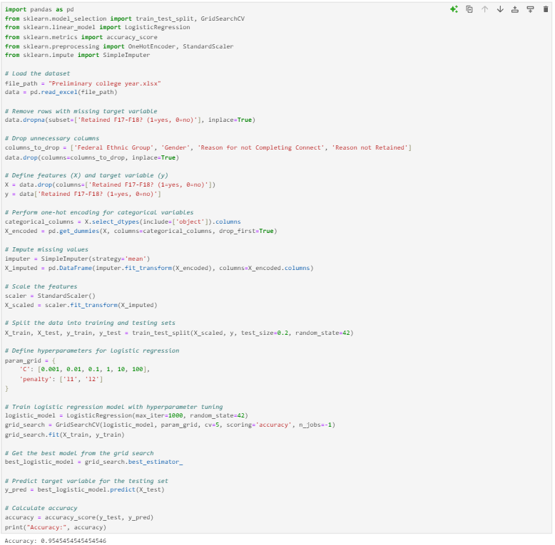

It was surprising to find that things like SAT scores and whether a student qualified for a Pell Grant didn’t seem to have as much impact on success as we originally thought. This means colleges should probably focus more on providing programs and resources that support students in non-academic ways. It would also be smart for colleges to watch out for students who might struggle academically or aren’t eager to accept assistance, as giving them extra support could improve graduation rates and keep more students engaged.

**7. Appendix C : Data and Code**

https://github.com/VigneshPambala/MTH-522-project-4.git

**8. Conclusion:**

Our analysis and logistic regression modeling of UMass Dartmouth’s preliminary year students provide a valuable tool for predicting academic success. By identifying key factors such as academic background and personal characteristics, the model allows us to estimate a student’s likelihood of passing the preliminary year with 95% accuracy. This high accuracy rate highlights the model’s effectiveness and potential as a proactive support resource.

With these insights, UMass Dartmouth and similar institutions can refine their support programs to better assist students who may be at risk. By tailoring interventions, mentorship, and resources to meet the needs of these students, universities can help more individuals succeed in their preliminary year, thereby paving a stronger path toward their academic goals. This approach not only improves student outcomes but also fosters a more supportive, resilient academic community.

**9. Reference:**

<https://www.dropbox.com/scl/fi/lxmhgobfbyqc9nc60f22p/Preliminary-college-year.xlsx?rlkey=7j0v9zd72n33mwmpxm3r9dhwq&e=1&dl=0>

https://mth522.wordpress.com/about/04-course-structure/project-3/

**10.Contributions:**

This project was a collaborative effort among three team members, each bringing unique skills and expertise to ensure its success. Together, the team worked to interpret the results from the logistic regression model, identifying key factors that influenced student success in the preliminary year and understanding which areas required additional support. The team collectively contributed to refining the model, adjusting various parameters to optimize accuracy and ensure reliable predictions. They also collaborated in selecting and analyzing relevant factors within the data, ensuring a thorough and insightful understanding of student outcomes.

Throughout the project, the team maintained a clear focus on creating a comprehensive and accessible report, presenting both the findings and recommendations in a way that could effectively guide the university in supporting students. This joint effort allowed the project to deliver clear and actionable insights for UMass Dartmouth to help students succeed in the preliminary year program.